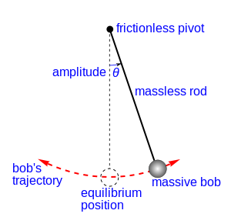**The Pendulum**

**Brought to you by Galileo**

Galileo discovered that the time it takes for a pendulum takes to swing to and fro through small distances depends only on the length of the pendulum and the acceleration of gravity. This to and fro motion is called simple harmonic motion. This is for small angles only.

simple pendulum

|  |  |
| --- | --- |
| [pendulum period](http://www.ajdesigner.com/phppendulum/simple_pendulum_equation_period.php) | Solve for period. |
| [pendulum length](http://www.ajdesigner.com/phppendulum/simple_pendulum_equation_length.php) | Solve for length. |
| [acceleration of gravity](http://www.ajdesigner.com/phppendulum/simple_pendulum_equation_gravity.php) | Solve for acceleration of gravity |

**Example Pendulum Problems:**

1. What is the period on Earth of a pendulum with a length of 2.4 m?
2. How long should a pendulum be in order to swing back and forth in 1.6 s?

**Pendulum Practice Problems: Answer on a separate sheet of paper!**

1. A grandfather clock needs to have a period of one second. What length of pendulum should be hung for the clock to keep good time?
2. If the clock from question 1 was taken to the moon where gravity is 1.7 m/s2, what length should the pendulum have?
3. A mountain climber, who has had physics in high school, figures out the gravity at his location in the mountains. He used a 4.0 m length of string and found that with a rock tied at its end, its period as a pendulum was 4.1 seconds. What was g at his location?
4. A ride at 6 Flags straps you in and you swing like a pendulum. The length of the cord that holds you is about 20 meters. How much time does it take to swing back and forth once?
5. A playground swing is 3 meters long. What is the period of the swing?
6. If we colonized Mars and took the swing-set from question 5 there, it would swing back and forth with a period of 5.7 seconds. What is the acceleration due to gravity on mars?
7. The desk toy with the swinging ball bearings has a length of 12 cm. What is the period of their swing?
8. A pendulum is 0.75 meters long and has a period of 4.17 seconds. Is this pendulum on the earth, moon, or mars? Do a calculation to prove your answer.
9. You are designing a pendulum clock to have a period of 1s. How long should the pendulum be?

10. A trapeze artist swings in simple harmonic motion with a period of 3.8 s. Calculate the length of the cables supporting the trapeze.

11. Calculate the period and frequency of a 3.5 m long pendulum at the following locations:

a. The North Pole where g = 9.832

b. Chicago where g = 9.803

c. Jakarta, Indonesia where g = 9.782